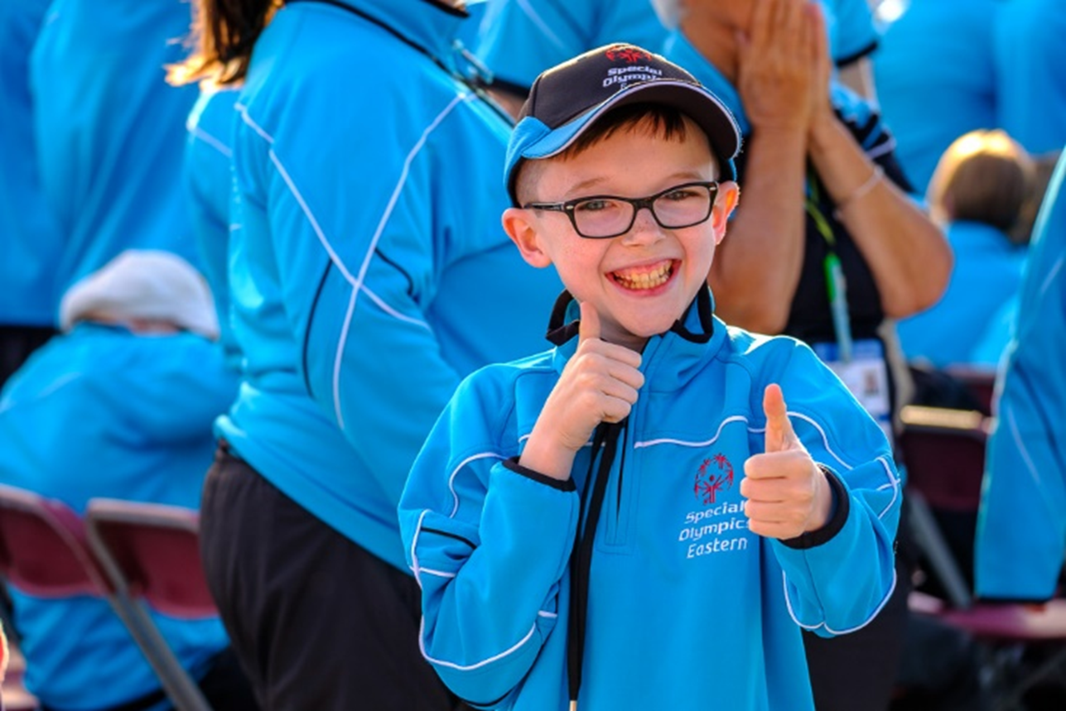VOicde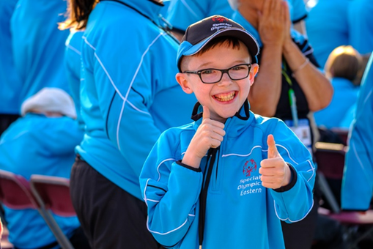

**\*Please note the following amendments to this document as of 10th September 2021**

With the further easing of restrictions in both Northern Ireland and the Republic of Ireland, Steps for a Club’s Return to Activities’ has been updated within this protocol.

**These guidelines should be read in conjunction with government and public health guidance on COVID-19 and the relevant National Governing Body of Sport guidance. Special Olympics Affiliated Clubs should also refer to the COVID-19 Safety Plan template when developing their Return to Activities Club Plan. These guidelines should be considered a ‘live document’ which will be updated to take account of any change in government or public health guidance as and when necessary.**

**RETURN TO ACTIVITES PROTOCOL**

# **UPDATES**

**Version 10.0 Issue Date: 10th September 2021**

Please note this version (10.0) supersedes all previous versions.

With the further easing of restrictions in both Northern Ireland and the Republic of Ireland, Steps for a Club’s Return to Activities’ has been updated within this protocol.

This protocol should be read in conjunction with:

* Government Guidelines
* Public Health Advice
* COVID-19 Safety Plan Template
* Club Templates

# **KEY CONTACTS:**

If you need assistance or have any queries on the Return to Activities Protocol please contact your local regional office at the details below:

**Special Olympics Connaught Region**

Regional Director: Myra Merrick Telephone: +353 71 9118320

Email: [myra.merrick@specialolympics.ie](mailto:myra.merrick@specialolympics.ie) Email: [connaught@specialolympics.ie](mailto:connaught@specialolympics.ie)

**Special Olympics Eastern Region**Regional Director: Oisin Jordan Telephone: +353 1 8912000  
Email: [oisin.jordan@specialolympics.ie](mailto:oisin.jordan@specialolympics.ie) Email: [eastern.region@specialolympics.ie](mailto:eastern.region@specialolympics.ie)

**Special Olympics Leinster Region**Regional Director: Annette Codd Telephone: +353 1 629 6999  
Email: [Annette.codd@specialolympics.ie](mailto:Annette.codd@specialolympics.ie) Email: [leinster@specialolympics.ie](mailto:leinster@specialolympics.ie)

**Special Olympics Munster Region**Regional Director: Eoin O’Beara Telephone: +353 21 4977192  
Email: [eoin.obeara@specialolympics.ie](mailto:eoin.obeara@specialolympics.ie) Email: [munster@specialolympics.ie](mailto:munster@specialolympics.ie)

**Special Olympics Ulster Region**Regional Director: Shaun Cassidy Telephone: (+44) 028 9023 9023  
Email: [shaun.cassidy@specialolympics.ie](mailto:oisin.jordan@specialolympics.ie) Email: [so.ulster@specialolympics.ie](mailto:so.ulster@specialolympics.ie)

# **TABLE OF CONTENTS**

**TABLE OF CONTENTS** 3

**1.** **INTRODUCTION** 4

**2.** **WHERE ARE WE NOW** 5

**2.1** **GUIDELINES** 5

**2.2** **KEY POINTS** 6

**2.3** **SOI RECOMMENDATIONS** 6

**2.4** **FACTORS IMPACTING THE RISK OF GETTING COVID-19 (DATES CONCEPT)** 7

**2.5** **OTHER FACTORS TO CONSIDER** 7

**3.** **KEY ACTIONS TOWARDS A SAFE RETURN TO ACTIVITIES** 9

**4.** **STEPS FOR A CLUB’S RETURN TO ACTIVITIES** 12

**5.** **ROLES AND RESPONSIBLITIES** 13

**6.** **PLANNING YOUR TRAINING SESSIONS – GUIDANCE FOR COACHES** 14

**6.1** **GUIDANCE FROM NATIONAL GOVERNING BODIES** 14

**6.2** **GUIDANCE FOR COACHES** 15

**6.3** **DATES FLOWCHART** 15

**7.** **GUIDANCE FOR ATHLETES, VOLUNTEERS, PARENTS, GUARDIANS & CARERS** 21

**7.1** **GUIDANCE IN RELATION TO ATHLETES** 21

**7.1.1** **Information Sheet for Athletes & Volunteers** 21

**7.2** **GUIDANCE IN RELATION TO VOLUNTEERS** 22

**7.2.1** **VOLUNTEER RETURN TO CLUB INFORMATION** 23

**7.3** **GUIDANCE IN RELATION TO PARENTS / GUARDIANS / CARERS** 24

**7.3.1** **PRE- TRAINING** 25

**7.3.2** **DURING TRAINING** 26

**7.3.3** **POST TRAINING** 26

**7.3.4** **SUSPECTED OR CONFIRMED CASE OF COVID 19** 26

**7.3.5** **PARENT / GUARDIAN / CARER ATTENDANCE AT SOI TRAINING SESSIONS / ACTIVITIES** 26

**8.** **MENTAL HEALTH & WELLBEING** 27

**9.** **SUSPECTED OR CONFIRMED CASE OF COVID-19** 28

**10.** **APPENDICES** 29

**TEMPLATES FOR CLUBS** 29

**NOTES ON THE TEMPLATES:** 29

# **INTRODUCTION**

**What is COVID 19?**

Coronavirus disease (COVID-19) is an infectious disease caused by Severe Acute Respiratory Syndrome Coronavirus2 (SARS-CoV-2). Most people (8/10) infected with the COVID-19 virus will experience mild to moderate respiratory illness and recover without requiring special treatment.  Older people, and those with underlying medical problems like cardiovascular disease, diabetes, chronic respiratory disease, and cancer are more likely to develop serious illness

**Identifying Symptoms**

The following symptoms may develop in the 14 days after exposure to someone who has COVID-19:

|  |  |
| --- | --- |
| * Cough * Difficulty Breathing | * Runny Nose * Flu Like Symptoms |
| * Fever/High Temperature * Sore Throat | * Rash * Loss of smell or taste |

It is important to note that some people infected with the virus, so called asymptomatic cases, can demonstrate no symptoms at all, yet can infect others. People who are showing these symptoms must not show up to training, self-isolate and report to their doctor for further information on COVID-19 testing.

**To prevent infection and to slow transmission of COVID-19, do the following:**

* Wash your hands regularly with soap and water or clean them with alcohol-based hand sanitiser.
* Maintain a distance of at least 2 metres / 6.5ft between you and another person.
* Avoid touching your face.
* Cover your mouth and nose when coughing or sneezing.
* Stay home if you feel unwell.

More information can be found here:

* Health Service Executive (HSE) - [Protect yourself and others from COVID-19](https://www2.hse.ie/conditions/coronavirus/protect-yourself-and-others.html)
* Public Health Agency (PHA) - [Preventing the spread of infection](https://www.publichealth.hscni.net/covid-19-coronavirus/covid-19-information-public#preventing-the-spread-of-infection)

**‘Who’ Is At High Risk from COVID-19**

The Health Services Executive (ROI) indicates that there are two (2) levels of high risk: (a) Very high risk and (b) High Risk- <https://www2.hse.ie/conditions/coronavirus/people-at-higher-risk.html>

The health department (NI) indicates that there are two (2) levels of high risk: (a) high risk and (b) moderate risk: <https://www.nhs.uk/conditions/coronavirus-covid-19/people-at-higher-risk/whos-at-higher-risk-from-coronavirus/>

If you have been diagnosed with COVID-19, an individual should consult with a doctor for written medical clearance before returning to Special Olympics activities in person as serious cardiac, respiratory, and neurological issues may develop as a result of COVID-19.

# **WHERE ARE WE NOW**

**Special Olympics Ireland (SOI)**

SOI suspended all club sports training and other person-to-person activities on March 10th 2020 and we are delighted that these activities are beginning to resume under current restrictions.

During the period of suspension and the transition to activities, Special Olympics Ireland developed the ‘Can’t Stop Now’ digital suite to assist clubs and coaches to keep connected with their athletes and the SO Ireland programme. The first stage of this initiative began in September 2020 following the Together at Home programme and the Summer Together at Home programme.

 The ‘Can’t Stop Now’ suite is still live and includes:

•         Together as Virtual Clubs

•         Health Promotion

•         Coach and Officials Development

•         Young Athletes™ programme

•         Strong Minds

Resources and further information on the can be accessed on our website here - [Can't Stop Now](https://www.specialolympics.ie/sport/cant-stop-now)

Staff members in the regional offices have and will continue to reach out to clubs to stay connected. The main focus now is to guide and support clubs, athletes, coaches and volunteers inpreparing for a return to club activities in a safe manner offering an engaging and enjoyable experience for our athletes.

At programme level, no competitions will take place until further notice. This includes, inter-club, leagues or advancement competition. It is important that athletes return to training first and rebuild their level of fitness and readiness for competition. 

A Return to Work Protocol is in place for staff members, most SOI staff will continue to work from home where possible.

**Club Level**

We hope that clubs continue to resume activities in person, albeit in a changed environment.  Each club will be making their own decision based on their timeframe for and success in meeting the criteria as set out in this Protocol. Guidelines are provided in terms of how the club can put measures in place to re-open and how to approach sports training sessions both indoor and outdoor.

# **GUIDELINES**

Special Olympics Ireland has developed this guidance document to help outline how a safe return to activities may take place. We have reviewed and incorporated guidance and information from various government and other sources and now set out the links to these reference sources below so that clubs may easily access the relevant information when developing their club plan.

The most recent guidance can be found here:

* [Reframing the challenge, continuing our recovery and reconnecting](https://www.gov.ie/en/publication/3361b-public-health-updates/)
* [Resilience and Recovery 2020-2021: Plan for Living with COVID-19](https://www.gov.ie/en/campaigns/resilience-recovery-2020-2021-plan-for-living-with-covid-19/)
* [The Executive's pathway out of restrictions](http://www.executiveoffice-ni.gov.uk/publications/executives-pathway-out-restrictions)
* [Sport Ireland Guidance](https://www.sportireland.ie/covid19)
* [Sport Northern Ireland Guidance](http://www.sportni.net/sportni/wp-content/uploads/2020/05/Framework-for-resumption-of-Sport-and-Physical-Recreation-in-NI-Final-version-1.pdf)
* Health Service Executive (HSE): <https://www2.hse.ie/coronavirus/>
* Health Prevention and Surveillance Centre: <https://www.hpsc.ie/az/respiratory/coronavirus/novelcoronavirus/>
* Department of Health Northern Ireland: <https://www.nidirect.gov.uk/campaigns/coronavirus-covid-19>
* Health Service Northern Ireland Public Health: <https://www.publichealth.hscni.net/>

# **KEY POINTS**

Each club has received an advance communication outlining the need to establish a COIVD-19 Coordinator and COVID-19 Safety Team to develop a club plan for a Return to Activities.

When planning for a Return to Activities, clubs should review Government Guidelines from their relevant jurisdiction in conjunction with this Return to Activities Protocol document. A COVID-19 Safety Template has been developed for clubs that will assist clubs to work through the process of putting a safe plan in place.

Other templates and information sheets to support the work that needs to be undertaken are available for clubs on our website [here.](https://www.specialolympics.ie/return-to-activity-templates-for-clubs)

If you would like to speak to a staff member about your Club’s return to activities please contact your Regional Staff Team, contact details can be found here - [Speak to a Staff Member](https://www.specialolympics.ie/return-to-activities/club-webinars-and-additional-support)

**At all times**,

* All Club attendees need to declare that he/she is symptom free from COVID 19 and complete the Pre-return Self Declaration form prior to returning to club activities.
* No attendee (athlete, parent/guardian/carer, coach or volunteer) should attend activities if unwell or any members of their household are unwell with symptoms consistent with COVID-19. The club will need to ask parents/guardians/carers to declare that their athlete is symptom free prior to returning to club activities and coaches should observe athletes for symptoms during club activities.
* Physical distancing, hand hygiene and good respiratory etiquette should be observed by all (athletes, parents/guardians/carers, coaches (and spectators, when permitted) in accordance with the Government and Special Olympics Ireland guidelines.
* Guidance on travel and face masks/coverings should also be observed.
* For full and up to date government guidance re the use of face coverings/masks please see the link [https://www.gov.ie/en/publication/aac74c-guidance-on-safe-use-of-face-coverings](https://www.gov.ie/en/publication/aac74c-guidance-on-safe-use-of-face-coverings/) or <https://www.nidirect.gov.uk/articles/coronavirus-covid-19-face-coverings>

# **SOI RECOMMENDATIONS**

**Mask Wearing**

Special Olympics Ireland recognises that the roll out of vaccinations are providing invaluable protection against COVID-19 however, the continuance of wearing masks is required by the organisation due to the health vulnerability of our athletes and the benefit of maintaining identified public health guidelines for infectious diseases.

Due to the health vulnerability of people with an ID, Special Olympics Ireland has taken the additional step of requiring mask wearing for club sessions.

* Mask to be worn on the way into and out of the venue and when moving within the venue (unless the individual is exempt)
* Athletes taking part in physical exercise are not required to wear a mask
* Mask to be worn by coaches and volunteers indoors (unless the individual is exempt)
* Recommendation that a mask is worn outdoors and must be worn where 2m distance cannot be maintained (unless the individual is exempt)

**IT IS EVERYONE’S RESPONSIBILITY TO KEEP THEMSELVES AND OTHERS SAFE AND HEALTHY.**

# **FACTORS IMPACTING THE RISK OF GETTING COVID-19 (DATES CONCEPT)**

|  |  |
| --- | --- |
| **DISTANCE** | The risk of getting COVID-19 increases as the distance between you and others get smaller. Keep 2 meters apart where possible. |
| **ACTIVITY** | How you spend time with people and what you do with them can increase your risk. |
| **TIME** | The more time you spend in close contact with other people can increase your risk of getting COVID-19. Keep track of who you spend time with and how. |
| **ENVIRONMENT** | Being outdoors is safer that being indoors. Where possible meet with others outdoors. If this is not possible, keep windows and doors open when meeting others inside. |
| **SPECIAL OLYMPICS** | Athletes with an intellectual disability should be able to return to sport once they are able to adhere to the measures in place to minimize the risks associated with COVID-19.  Always assess your attendees’ needs and ability to comply with guidelines.  Specific considerations may include reduced numbers in comparison to mainstream guidelines or where more detail is required to manage close contact or required assistance.  At-risk athletes and volunteers are advised not to attend activities. |

# **OTHER FACTORS TO CONSIDER**

When planning for a return to activities, consider:

1. **Ability of the Club to offer all athletes the opportunity to take part in the same number of activities that they took part in before COVID-19.**

Clubs need to look at each sport and activity that they offer and agree the number of athletes that they can offer the opportunity to attend training or the activity in order to be compliant with Government and Special Olympics Ireland guidelines.

Consideration needs to be given to:

* + Training/ Activity requirements: size of training venue, number of lanes required etc.
  + Duration of training/activity: time available to train or host the activity.
  + Number of Athletes participating in the activity.
  + Specific needs and requirements of the athletes.
  + Number of volunteers available to support.

To support all athletes and volunteers interest in returning to club activity it is suggested to ask all attendees to complete an interest survey preference for activity/sport.

It is advised that Clubs set expectations with athletes and families for an initial period of time and reduce the number of activities that an attendee may participate in.

1. **The level of contact involved in the sport**

Different activities and sports carry different degrees of risk related to the level of close contact involved. Team sports for example can largely be categorised into contact and non-contact sports, with contact sports carrying a higher risk of virus transmission:

*Contact sport* is an activity, particularly a team activity, in which by participating you are coming into close contact with others as part of competing or taking part in that activity – for example, physical contact sport in sport where there is close contact like football, basketball and floorball.

*Non-contact sport* – activities in which you can comfortably maintain 2 metres distance from others while participating – for example athletics, table tennis or golf.

1. **The risk level for each of the individual participants** 
   1. The ability of the participants to maintain 2 metres physical distancing rules
   2. If there are any concerns regarding an athlete’s susceptibility to COVID-19 due to an underlying illness, their parent/guardian/carer should discuss this with their medical practitioner prior to a return to club activities.
   3. The age of the athlete - a very young athlete may have less understanding of physical distancing and hygiene measures and therefore return to activities may be most appropriate on an individual or small group basis, practicing skill, without physical contact between participants, and where physical distancing is more manageable.

1. **Orientating Athletes into Activities**

It is important to recognise that many of our athletes may have been experienced more isolation than other individuals in society as their regular day-to-day structure, networks and supports that they rely on may have been closed, reduced or conducted through a virtual environment. Athletes will be excited at the prospect of returning to meet their friends and play their sport.

The environment and the experience for athletes will be much different from when they last took part in club training or other activities. In the absence of their regular day-to-day structured activities, Special Olympics activities may be their first encounter with others outside their home. We recommend that clubs and coaches:

1. Communicate the new measures, responsibilities and requirements to all attendees and
2. Provide a briefing and walk-through at the start of each session to educate and reinforce the measures.
3. **Grouping of athletes and volunteers.**

In order to protect attendees at activities; it is advised that athletes are grouped together and assigned volunteers to support for the duration of the session.

# **KEY ACTIONS TOWARDS A SAFE RETURN TO ACTIVITIES**

1. **Establish a COVID-19 Safety Team**

Clubs are required to establish a COVID-19 Safety Committee, led by a COVID-19 Coordinator who will oversee the planning and implementation of the club’s Return to Activities plan. Where clubs offer more than one activity, whether that is different sports training sessions, Young Athletes Programme, Health Promotion or Athlete Leadership activities, it is recommended that a COVID-19 Activity Lead is appointed for each activity.

1. **Conduct a Return To Activity Risk Assessment**

Any return to activities will involve the undertaking of a risk assessment to determine the risk level for COVID-19 transmission related to the particular activity or sport, and what additional measures are needed to reduce this risk.

The additional measures, called Control Measures, will consist of reasonably practicable measures, to mitigate or eliminate hazards that create risk. The objective is to reduce, either immediately or within a reasonable timeframe, the level of risk completely or to a tolerable or acceptable level. The COVID-19 Safety Plan [Template](https://www.specialolympics.ie/sport/return-to-activities/club-information/return-to-activity-templates-for-clubs) contains a Risk Assessment template that outlines a number of significant areas where control measures will need to be considered.

1. **Develop and Implement a COVID-19 Safety Plan**

A COVID-19 Safety Plan [template](https://www.specialolympics.ie/sport/return-to-activities/club-information/return-to-activity-templates-for-clubs) has been developed for use by clubs. The COVID-19 Safety Plan should outline how the club will manage training and club activities in order to minimise the spread of COVID-19 and safeguard members from the risk of infection. The COVID-19 Safety Plan allows the club to:

* Demonstrate compliance with Government and Health Authority guidance
* Identify and outline specifics arrangements to managing the risks of COVID-19 at their club
* Delineate key roles and responsibility with respect to managing against COVID-19

1. **Develop a Suspected Case Response Plan**

As part of the COVID-19 Safety Plan, the club will be required to outline how they will respond to a suspected case once an attendee presents or is identified as having possible symptoms. Further guidance and sample plan is provided within the COVID-19 Safety Plan [template](https://www.specialolympics.ie/sport/return-to-activities/club-information/return-to-activity-templates-for-clubs).

1. **Source Personal Protection Equipment (PPE), Supplies and Signage**

A list of PPE and supply items is supplied in the Safety Plan Template. Clubs will need to source these items.

1. **Engage and Communicate with Athletes, Parents/Guardians/Carers, Coaches and Volunteers**

It is recommended that clubs engage with athletes, parents/guardians/carers, coaches and volunteers in advance of the timeframe for the club’s return to activities. Some individuals may be anxious, have concerns or may not be in a position to return. Any return should be on an opt-in basis for all individuals. Clubs should afford individuals to take personal responsibility to decide whether or not they are happy to return. By engaging early, clubs will establish the numbers that are likely to return when the club is able to open. It will be critical to establish whether there will be a sufficient number of volunteers available to allow the club to provide the required supervision, as well as manage the new measures required. The club should communicate the new measures that will be in place to help minimise and manage the risks posed by COVID-19.

Previous and any upcoming webinars on Supporting Safe Return to Club Activities during Covid-19 can be viewed on our website [here](https://www.specialolympics.ie/sport/return-to-activities/club-information/club-webinars-and-additional-support).

1. **Educate all Stakeholders on COVID-19 Symptoms, Risks and Control Measures and Responsibilities**

The COVID-19 Coordinator, COVID-19 Safety Team, including the COVID-19 Activity Lead(s) should complete the [**Sport Ireland COVID-19 Return to Sport e-Learning Course**](https://www.sportireland.ie/covid19/course)**.**

Parents/Guardians/Carers, Athletes (where feasible), coaches and volunteers all need to be made aware of the symptoms of COVID-19 and should also complete the [**Sport Ireland COVID-19 Return to Sport e-Learning Course**](https://www.sportireland.ie/covid19/course)**.**

Athletes, Coaches and Volunteers will be expected to comply with a [COVID-19 Code of Conduct.](https://www.specialolympics.ie/sport/return-to-activities/club-information/return-to-activity-templates-for-clubs)

Special Olympics Clubs should ensure that all attendees are educated about those that are at higher risk of complications from COVID-19 as well as all procedures and expectations for return to activities.

All individuals need to understand the need to immediately self-isolate for 14 days and to phone their doctor in the event of onset of any COVID-19 signs or symptoms or to restrict their movement if they have had recent close contact with a suspect or confirmed COVID-19 case. Further information on when and how to self-isolate and restrict movement are also available on the Health Services Executive (HSE) in ROI and Department for Health in NI websites.

1. **Pre-Return Declaration Form and COVID-19 Code of Conduct Form to be Completed**

Athletes, coaches and volunteers returning to club activities will be required to complete the two forms which can be downloaded from our website [here.](https://www.specialolympics.ie/return-to-activity-templates-for-clubs)

If any athlete/ volunteer has tested positive and/or been diagnosed with COVID-19, the athlete/ volunteer must provide written proof of clearance from their healthcare professional prior to returning to sport, fitness or any Special Olympics activity.

1. **Maintain a Contact Log for Contract Tracing Measures**

A log of all athletes, volunteers or other individuals attending every activity session, with access to contact information for contact tracing purposes must be recorded to enable contact tracing should it be required. This log should be electronic and should be completed in advance where possible. There should be a system in place where this log is updated in real time for any necessary changes. This log should be readily and quickly accessible for contact tracing purposes.

A contact log template can be downloaded from our website – [here.](https://www.specialolympics.ie/return-to-activity-templates-for-clubs)

1. **Review COVID-19 Action List/Check List Before and After Each Activity**

COVID-19 Activity Lead(s) will be required to carry out routine checks before and after each session. The checks should be completed and signed off by the COVID-19 Coordinator for each training session and provided or made available to the COVID-19 Coordinator for monitoring purposes.

Club checklists templates can be downloaded from our website – [here.](https://www.specialolympics.ie/return-to-activity-templates-for-clubs)

1. **Confirming Readiness**

When a club has completed the key actions outlined above, and are able to confirm that the required measures are in place; the club must confirm their readiness to resume club training via our website [here.](https://www.specialolympics.ie/confirm-your-clubs-return-to-training)

SOI are requesting that athletes and volunteers go through an orientation period to adjust and adapt to their new club environment. We want all attendees to have a positive experience on their return, but safety is paramount.

Outdoor Sport

By confirming this readiness; clubs also agree to complete a minimum of 1 week non-contact training (**orientate**) before resuming full training (**reactivate**) for outdoor sports.

Indoor Sport

By confirming this readiness; clubs agree to remain at the Orientate step until the end of October (subject to Government Guidelines) or as advised by SOI.

As this is an ever-evolving situation, affiliated clubs may need to revert back to an earlier step at different time

# **ROLES AND RESPONSIBLITIES**

In planning for a return to activities, **Special Olympics Ireland (SOI) responsibilities** are as follows:

* Develop the SOI Return to Activities Protocol, setting out information in relation to government guidance on COVID-19 and SOI guidance for a safe return to club activities.
* Monitor ongoing public health advice and update the Protocol where required, advising clubs on any new information, guidance, measures, restrictions or other as necessary.
* Consult and provide support to clubs on managing a safe return to club activities.
* Provide information documents, templates and reference links to help clubs to undertake risk assessment activities and to develop a COVID-19 Safety Plan.
* Organise and manage Special Olympics Ireland/Regional activities as and when these resume.
* Develop Return to Work Protocol for SOI staff and Support Centre Volunteer Team.

**Responsibilities of the club are as follows:**

* Review the Return to Activities Protocol and guidance to understand and address measures to manage and control risks associated with COVID-19.
* Stay informed and up-to-date on public health guidance on COVID-19.
* Appoint a COVID-19 Coordinator and Safety Team to oversee the planning for re-opening of club activities.
* Conduct a Risk Assessment for each venue that the club uses for its activities.
* Develop and implement a COVID-19 Safety Plan.
* Prepare a detailed response plan to deal with a suspected COVID-19 case.
* Display information on COVID-19 at activity locations.
* Engage with volunteers, parents/guardians/carers and athletes in advance of re-opening and provide information on the club’s plan for a safe return.
* Induction and training provided for all attendees and update as required.
* Ensure all participants complete a Pre-Return to Activities Self-Declaration Form and COVID-19 Code of Conduct.
* Maintain records (electronic recommended) of attendance at activities to facilitate contact tracing should the need arise.
* Agree a process for check in on arrival of athletes and volunteers for compliance with COVID- 19 measures at training sessions to include physical distancing guidelines.
* Conduct and complete the activity check list and monthly coordinator checklist.
* Monitor Risks and review and/or amend controls when identified as necessary.
* Confirm readiness to return to training

**Roles within the club.**

Clubs will have received previous communication regarding the specific COVID-19 Management roles required within your club.

Detailed role descriptions of each of the roles listed below can also be found in Section 3 of the Safety Plan template:

* Club Management Team
* COVID-19 Safety Team
* COVID-19 Coordinator
* COVID-19 Activity Lead(s)

# **PLANNING YOUR TRAINING SESSIONS – GUIDANCE FOR COACHES**

# **GUIDANCE FROM NATIONAL GOVERNING BODIES**

The Special Olympics Programme offers 14 official sports, a non-competitive Motor Activities Training Programme and a Young Athletes™ programme. The diversity within this range of sports brings a layer of complexity when implementing the above steps.

To overcome this complexity, we recommend that each club reads and understands the guidance issued by Special Olympics Ireland but also review the guidance provided by the relevant National Governing Body (NGB) of the particular sport(s) run in the club.

|  |  |
| --- | --- |
| **National Governing Body of Sport** | **Website – Return to Sport Protocol** |
| Alpine Skiing | [www.snowsports.ie](http://www.snowsports.ie/) |
| Athletics | [www.athleticsireland.ie](http://www.athleticsireland.ie)  [www.athleticsni.org](http://www.athleticsni.org) |
| Badminton | [www.badmintonireland.com](http://www.badmintonireland.com/) |
| Basketball | [www.basketballireland.ie](http://www.basketballireland.ie/) |
| Bocce | [www.irishbowlsfederation.co.uk](http://www.irishbowlsfederation.co.uk/) |
| Equestrian | [www.horsesportireland.ie](http://www.horsesportireland.ie/) |
| Floorball | [www.hockey.ie](http://www.hockey.ie/) |
| Football | [www.fai.ie](http://www.fai.ie)  [www.irishfa.com](http://www.irishfa.com) |
| Golf | [www.golfnet.ie](http://www.golfnet.ie/) |
| Gymnastics | [www.gymnasticsireland.com](http://www.gymnasticsireland.com)  [www.british-gymnastics.org/northern-ireland](http://www.british-gymnastics.org/northern-ireland) |
| Kayaking | <https://canoe.ie/>  [www.cani.org.uk](http://www.cani.org.uk) |
| Motor Activities | [www.hpsc.ie](http://www.hpsc.ie/) |
| Pitch and Putt | [www.ppui.ie](http://www.ppui.ie/) |
| Swimming | [www.swimireland.ie](http://www.swimireland.ie/) |
| Table Tennis | [www.irishtabletennis.com](http://www.irishtabletennis.com/) |
| Ten Pin Bowling | [www.tenpinbowling.ie](http://www.tenpinbowling.ie)  <https://nitbf.org.uk> |
| Young Athletes™ programme | [www.hpsc.ie](http://www.hpsc.ie/) |

# **GUIDANCE FOR COACHES**

SOI developed a series of flowcharts to assist coaches in making good decisions on how training sessions can be organised safely and to take account of COVID-19 guidelines for all attendees. The flowcharts are based on the governments **DATE** concept - **D**istance **A**ctivity **T**ime and **E**nvironment and SOI has added an “**S**” for Special Olympics specific content. The **DATES** concept will assist coaches to make good decisions for their athlete group and recognises that no two clubs are the same. These flowcharts should be reviewed prior to reviewing and taking account of the relevant National Governing Body (NGB) for Sport to ensure best practice is employed for Special Olympics club activities.

Floorball, Bocce, Motor Activities Training Programme and Young Athletes™ are sports/programmes for which Special Olympics Ireland is the National Governing Body. For two of these sports, SOI is signposting coaches to NGB guidance in a sport that is similar in nature, namely Hockey Ireland for Floorball and Irish Lawn Bowls for Bocce.

In the case of the Motor Activities Training Programme and Young Athletes™, clubs should refer to the recommendations outlined in the publication “[COVID-19 Interim Recommendations for the Return to Sports Activities for Children and Adolescents](https://www.hpsc.ie/a-z/respiratory/coronavirus/novelcoronavirus/guidance/sportandrecreation/)”, issued by the Health Protection Surveillance Centre (HPSC).

**Key Points**

* Where a difference exists between the relevant NGB guidance and that of Special Olympics Ireland, clubs should follow Special Olympics Ireland guidance. An example of this is in the ‘Orientation’ phase for a club’s returned outlined in SOI’s Protocol, the number of attendees is likely to be lower than that permitted by some other NGBs.
* Some Special Olympics athletes may need more assistance than others, increasing physical contact than the NGB guidelines may anticipate and it is hoped the ‘S’ in DATES will help identify these situations.
* Coaches should be mindful that some athletes will have been relatively inactive for up to 18 months and the level of fitness is unlikely to be at the level it may have been in March 2020. Therefore, the duration and intensity of training should not be at the same level that it was back in March 2020. Sessions will need to be adapted to suit each athlete group and to facilitate a gradual return to fitness and skill level.
* It is important to note that some athletes may choose not to return to the club for a variety of reasons, for example, they may require additional assistance, have underlying health issues or be anxious about the return. We hope that, in time, all athletes will make a return and the club is active again and meeting the needs of all its athlete members.

# **DATES FLOWCHART**

The following flowcharts should assist coaches when planning their training session.

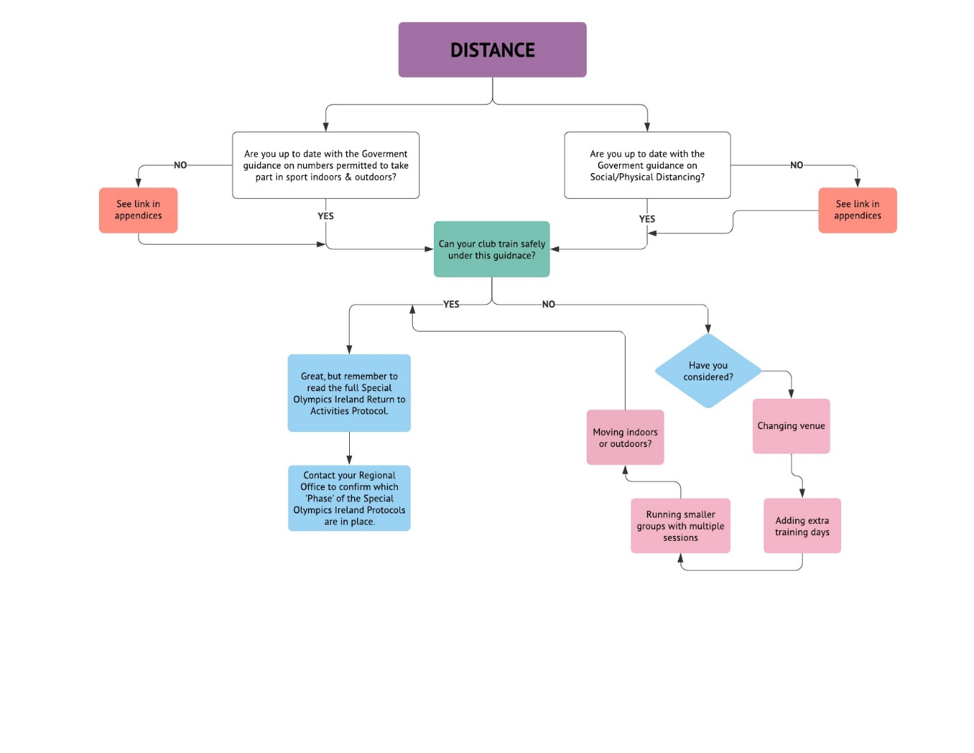

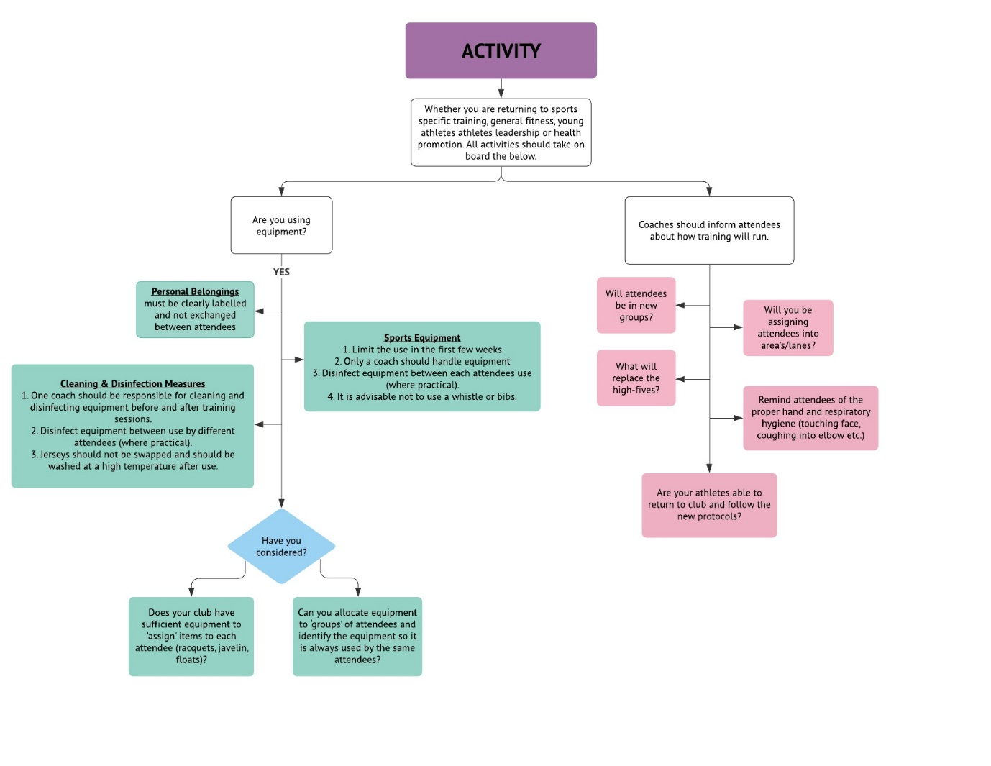



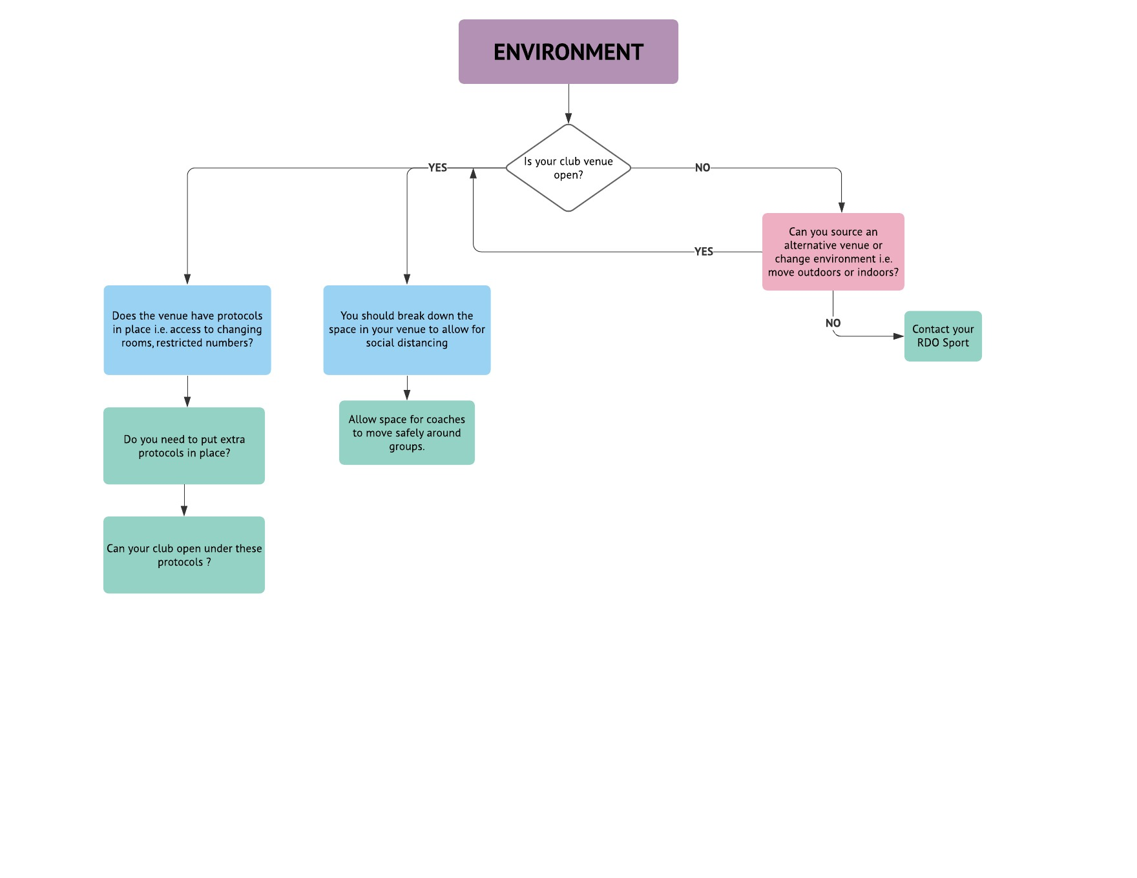

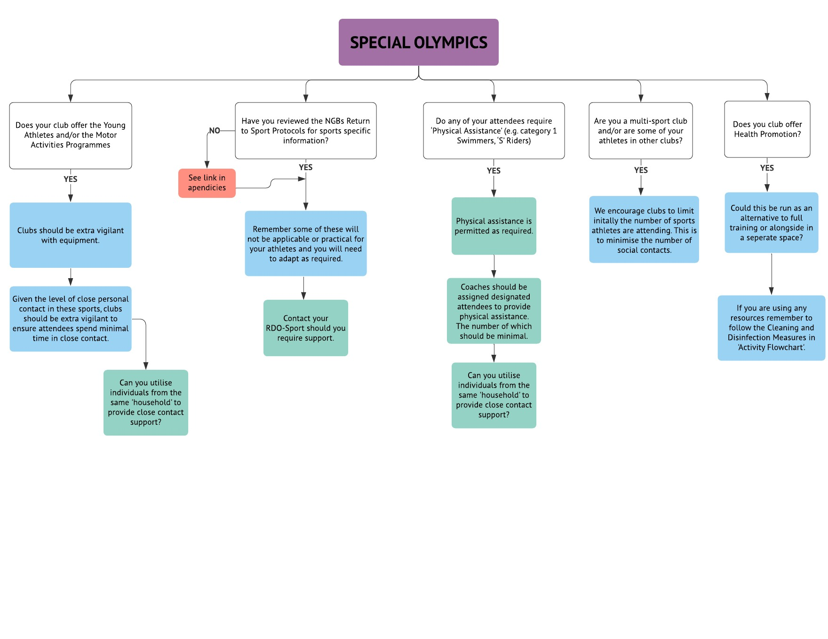

# **GUIDANCE FOR ATHLETES, VOLUNTEERS, PARENTS, GUARDIANS & CARERS**

# **GUIDANCE IN RELATION TO ATHLETES**

Athletes of the clubs have a responsibility to act in a safe and respectable manner while at training or club activities. Failure to do so could result in the formation of clusters at the club endangering the wider community.

All athletes should be advised to:

* Complete a Pre-Return Self Declaration and COVID-19 Code of Conduct Form and send to COVID-19 Coordinator / COVID-19 Activity Lead(s) via email or online as appropriate, a minimum of 3 days before returning.
* Make themselves aware of the symptoms of COVID-19 and monitor their own wellbeing.
* Do not attend club activities if they feel unwell.
* Participate in the induction, and any training provided by the Club.
* Adhere to practice a high level of personal hygiene and physical distancing.
* Be open and honest if they have been in contact with a COVID-19 case or suspected case.
* When attending Club activities to bring own drinking bottle and any other personal equipment required.
* Agree to only share when instructed to and ensure prior to use it is disinfected.
* In travelling to Club activities ensure to only travel with individuals from own place of residence and if public transport is utilized to adhere to government requirements.
* Keep a contact log of direct contact with other people and ensure their next of kin is on file.
* Athletes must inform the COVID-19 Coordinator/Activity Lead or their Coach if they become unwell outside of Club activity; and if they have or are suspected of having COVID-19.

Guidance on what to do is included in Section 9 - SUSPECTED OR CONFIRMED CASE OF COVID-19

# **Information Sheet for Athletes & Volunteers**

|  |  |
| --- | --- |
| hand | Remember to wash your hands before going to training and use sanitiser when you get to your club. |
| bottle | Bring your own water bottle with your name clearly marked on it and come dressed ready for training. |
|  | You should only travel to your activity with members from your own home/place of residence.  If using Public Transport a face mask must be worn as per COVID-19 Government guidelines. |
| social d | Follow instructions from your coaches and volunteers about keeping your distance. |
| cough | Cough or sneeze into your bent elbow or tissue. If using tissues throw it in the rubbish bin and wash your hands. |
| bow | Use a bow to say hello or foot bump to say well done.  NO shaking hands, high fives or hugs. |
| bye | After training go straight to your car and wash your hands when you get home. |

# **GUIDANCE IN RELATION TO VOLUNTEERS**

Volunteers will play a critical role in enabling the club to return to activities. We advise the club Management Team engages with each volunteer, either via telephone or email, to establish if they are in a position to return and/or whether they have any concerns. A follow up communication should include the measures the club is putting in place to manage the safe return for all. The Health Service Executive / Public Health Agency have some posters and resources that can be used in preparation for return to club activities <https://www.hse.ie/eng/services/news/newsfeatures/covid19-updates/partner-resources/> or <https://www.publichealth.hscni.net/publications?keys=coronavirus>

It is important for the Club Management Team to get an understanding from each volunteer of their well-being and how they feel about returning to volunteering. Each volunteer will have been impacted by the pandemic in different ways and have different outlooks on how they as an individual move forward and this needs to be taken into consideration.

Some volunteers may be feeling anxious about returning, have questions about how the health and safety measures will be implemented. Some may not feel ready to returning to volunteer at the current time or may not want to return at all. It is essential that they may voice any concerns and not feel guilty if they make the decision to withdraw from volunteering either temporarily or permanently. Collating this information from club volunteers will help identify if there is going to be any resourcing shortfall(s), which may lead to other consideration of the return date and participant numbers that can be managed safely.

Crucial to a positive and safe return to activity is good communication and a collaborative approach between all members of the club.

SOI has developed a template communication to support the club’s engagement with their volunteer; which can be downloaded from our website [here.](https://www.specialolympics.ie/return-to-activity-templates-for-clubs)

On return to activity in the club, volunteers must be advised to inform the Club COVID-19 Coordinator/ Activity Lead if they become unwell outside of Club activity; and if they have or are suspected of having COVID-19. Guidance on what to do is included in Section 9 - SUSPECTED OR CONFIRMED CASE OF COVID-19

# **VOLUNTEER RETURN TO CLUB INFORMATION**

**Be Responsible. Be Safe**

**Be Responsible**: Familiarise yourself with these guidelines before you return to volunteer at the club.

**Be Safe**: Cooperate with the measures the club are implementing to keep athletes and volunteers safe.

*Returning to Volunteering:*

Our club has been putting protocols in place to get athletes safely back to some club activity. We are contacting you to check how you feel about returning to volunteering. If you don’t feel you are ready to return to volunteering just yet, it’s ok to say no. Please look after your health. The club may be restricted in numbers returning and have a phased approach to returning to club activities. Please understand that any decisions made by the club is to ensure that measures for everyone’s safety can be implemented. You may wish to return to volunteering but the club may not be able to accommodate you immediately.

*Key Guidelines*

* Before you return to volunteering at your club
* Volunteering at your club
* Using equipment at your club
* Leaving the club at the end of the activity

*Before you return to Volunteering at Your Club:*

* Complete Sports Ireland’s [**Sport Ireland COVID-19 Return to Sport e-Learning Course**](https://www.sportireland.ie/covid19/course)**.**
* Prior to returning to volunteer at the club, you will need to complete a Pre-Return Self Declaration Form. This form will be issued by your club and will also be available to download from our website [here.](https://www.specialolympics.ie/return-to-activity-templates-for-clubs)
* The Pre-Return Self Declaration Form reminds you that you must stay at home if you:
  + Have been in contact with someone with COVID-19 within 14 days prior to return
  + Have been overseas less than 14 days prior to return
  + Have symptoms such as cough, fever, high temperature, sore throat, runny nose, breathlessness or flu like symptoms within the last 14 days of returning
  + Have been diagnosed with confirmed or suspected COVID-19 infection in the last 14 days prior to returning
* You are advised to check with your General Practitioner (GP) prior to returning to volunteering if you are in a High Risk health category

We would encourage you to review the guidelines in terms of risk categories.

<https://www2.hse.ie/conditions/coronavirus/people-at-higher-risk.html>

<https://www.nhs.uk/conditions/coronavirus-covid-19/people-at-higher-risk/whos-at-higher-risk-from-coronavirus/>

*Volunteering at your club*

* Wash your hands before you leave your house and travel to the club, either alone, or if you need to, with members of your own household.
* Bring your own water, tissues and hand sanitiser.
* Arrive ready to go as access to facilities may be limited.
* Arrive as close as possible to when you are due at the club.
* Follow your clubs guidelines for check-in.
* Observe physical distancing guidelines and keep this distance between yourself and others.
* Encourage athletes to use alternative greetings, e.g., thumbs up or hands crossed over chest.
* Do not share food, towels or drinks.
* Try not to touch any surfaces, but if you do, sanitise your hands as soon as possible.
* Cover your coughs and sneezes. If using tissues throw them in the rubbish bin or dispose of any used tissue in your own bag and bring it home with you. Sanitise or wash your hands.
* Reinforce physical distancing with athletes and congratulate when you see them applying the guidelines.
* Only travel to the activity with members of your own household.
* If using Public Transport, a face mask must be worn as per COVID-19 Government guidelines.
* Avoid touching your face.
* If you become unwell during an activity, you must communicate this to the COVID-19 Activity Lead at the session, who will then put in place their Response Plan for a Suspected Case of COVID-19.
* If you become unwell outside of Club activities or if you have / are suspected of having COVI-19 you must inform the Club COVID-19 Coordinator.

**Using equipment at your club**

* Guidance will be provided by the coach as to when and how equipment may be shared.
* When sharing of equipment is permitted, it will require sanitizing between users.
* Watch out for athlete’s use of equipment and ensure proper sanitization after use.

**Leaving the club at the end of the activity**

* Don’t hang around, leave the club promptly.
* Hands should be washed and sanitised as soon as possible.
* Travel home alone or with people from your household only.
* If you become unwell after a club activity session, contact your General Practitioner (GP) and read the Health Service Executive (HSE) / Public Health Agency (PHA) guidelines and inform your club.

A sample email to volunteers in the club as part of your club’s pre-activity engagement can be downloaded from our website [here.](https://www.specialolympics.ie/return-to-activity-templates-for-clubs)

# **GUIDANCE IN RELATION TO PARENTS / GUARDIANS / CARERS**

Parents/Guardians/Carers have an important role to play to support athletes and the club in making a safe return to activities. Each will need to know and understand the control measures in place in the club when activities resume. In particular, they will complete or support their athlete to complete the Pre-Return Self Declaration Form. Understanding and monitoring of the symptoms of COVID-19 will be a continuous responsibility in relation to their athlete and for the safety of other athletes and volunteers in the club. . The club will need to establish if there has been any change in the athlete’s general health status or relevant new medical information, since the cessation of club activities in March 2020.

Younger athletes and some adult athletes will need their parents/guardians/carers to spend time with them to educate (explain and outline) on the measures that will be in place and the clubs expectations in relation to the COVID-19 Code of Conduct.

Athletes in Special Olympics are generally more reliant on their parents/guardians/carers or other family members when it comes to getting to and from their activities. Parents/Guardians/Carers may, in the past, have relied on others to assist/share (car-pooling) the transportation of athletes to and from their home/place of residence for club activities. SOI recommends that only individuals from the same home/place of residence travel to and from training together in a car. Car-pooling is not permitted under current guidelines. Observation of physical distancing guidelines are expected during drop off and pick up of athletes and this may mean that some may remain in their vehicle until it is safe to exit.

We advise that clubs engage with parents/guardians/carers to establish it an athlete is in a position to return and to establish if they have any concerns in relation to the re-opening of the club. A follow up communication should include the measures the club is putting in place to manage the safe return for all. Parents/Guardians/Carers, like volunteers, will have been impacted by the pandemic in different ways and may have different outlooks on how they as an individual move forward. They may be feeling anxious about their athlete returning and/or have questions about how the health and safety measures will be implemented.

# **PRE- TRAINING**

All Parents/Guardians/Carers are required to:

* Ensure that they and are fully aware of the guidelines on the Return to Activities Protocol.
* Complete the [**Sport Ireland COVID-19 Return to Sport e-Learning Course**](https://www.sportireland.ie/covid19/course)**.**
* Complete the pre-return self-declaration form in advance of the first club session and return it to the COVID-19 Coordinator via email or online as appropriate 3 days before your return.
* Continue to monitor their athlete’s temperature before each training session.
* Inform the COVID-19 Coordinator or Activity Lead of any change in their athlete’s health.
* Travel to training with members from their own house/place of residence.
* Ensure that the athlete has washed their hands before travelling to training.
* Ensure that the athlete attends club dressed for training, with a water bottle and all personal items labelled.
* Encourage their athlete to use the bathroom prior to leaving home to minimise the use of bathrooms within the training venue.
* Please bring hand sanitiser / wipes for your athlete if deemed appropriate.
* Parents / Guardians / Carers should adhere to the physical distancing guidelines when dropping their athlete at club facility. Drivers must drop off their athlete and leave or wait in their cars. Parents / Guardians / Carers will only be permitted to remain on site at the session if there is a defined need to support their athlete i.e. bathroom use.

# **DURING TRAINING**

Parent/Guardian/Carer should inform their athlete that they:

* Must use their own water bottle at all times.
* Cough or sneeze into their bent elbow or tissue. If using tissues throw them in the rubbish bin or dispose of any used tissue in your own bag and bring it home with you. Sanitise or wash their hands.
* Must refrain from shaking hands, high fives or hugs. Use bowing and foot bump instead.
* Follow instructions from their coaches & volunteers about keeping their distance.

# **POST TRAINING**

* Athletes must leave immediately after training with members from their home / place of residence.
* Parent/Guardian/Carer should collect their athlete on time from the collection area as advised by the club & avoid any physical contact with others.
* Athletes must wash their hands & shower at their home / place of residence.
* Parent/Guardian/Carer should ensure that all personal gear and equipment is taken away with them and appropriately cleaned prior to the next club session.
* Parents/guardians/carers must inform the Club COVID-19 Coordinator/Activity Lead if the athlete becomes unwell outside of Club activity and has or is suspected of having COVID-19.

# **SUSPECTED OR CONFIRMED CASE OF COVID 19**

All parents/guardians/carers / athletes to be reminded that they MUST stay at their home / place of residence, if they are sick or showing signs and symptoms of COVID-19. In such circumstances, the individual should telephone their GP for advice.

Parents/guardians/carers must inform the Club COVID Coordinator/Activity Lead if the athlete becomes unwell outside of Club activity and has or is suspected of having COVID-19. Guidance on what to do is included in Section 9 - SUSPECTED OR CONFIRMED CASE OF COVID-19

# **PARENT / GUARDIAN / CARER ATTENDANCE AT SOI TRAINING SESSIONS / ACTIVITIES**

 The recent Regulations announced by Government aim at decreasing the congregation of groups in social settings and to assist with contact tracing where required. Public health and reducing the risk of Covid-19 transmission remains the overarching priority.

It is acknowledged that some parents/guardians/carers may wish to attend training / activities in a supervisory capacity or if there is a specific need to assist the athlete.

Each club will need to determine if they can facilitate such attendance. Clubs who choose to permit attendance should ensure that strict adherence to physical distancing and public health guidelines is maintained at all times. At a minimum, the following measures should be implemented by Clubs:

1. No more than 1 designated individual attending the session per child/family/group of children.
2. Overall numbers are kept to a minimum and in line with the space available in the venue/facility.
3. Pre-return Self Declaration and COVID-19 Code of Conduct Forms must be completed by all parents/guardians/carers as well as their athlete in advance of attendance.

Each Club must ensure that there are robust mechanisms in place to limit overall numbers, assist with contact tracing and implement compliance with physical distancing and other public health guidelines.

# **MENTAL HEALTH & WELLBEING**

Infectious disease pandemics like coronavirus (COVID-19) can be worrying. Some people might find it more worrying than others. This can have an impact on our mental health. Clubs should consider ways in which it can support its members in safeguarding their mental health.

Clubs should seek to support mental health and wellbeing by:

* Providing information about prevention and the control measures in place at the club will be delivered to all members and staff to help ease concerns about risk of infection.
* Encouraging healthy eating, exercising, getting sleep, and finding time to unwind.
* Ensuring details for publicly available sources of support and advice available for members.

**The following are various resources to support Mental Health and Wellbeing:**

Special Olympics Strong Minds Resources:

<https://www.specialolympics.org/our-work/covid19#strong-minds>

Special Olympics Strong Minds Activity Cards: <https://media.specialolympics.org/resources/health/disciplines/strongminds/Strong-Minds-YA-Activity-Cards-08-2020.pdf?_ga=2.133562889.626445031.1611848552-1276003366.1584525278>

Strong Minds Tips for Keeping a Strong Mind:

<https://media.specialolympics.org/resources/covid-19/Tips-for-keeping-a-strong-mind.jpg?_ga=2.166732094.1840808347.1594799444-1276003366.1584525278>

Strong Minds Tips for getting a Good Night’s Sleep:

<https://media.specialolympics.org/resources/covid-19/Tips-for-keeping-a-strong-mind.jpg?_ga=2.106833155.1840808347.1594799444-1276003366.1584525278>

Health Services Executive Resources for Supporting Someone with Special Needs:

<https://www2.hse.ie/wellbeing/supporting-someone-with-special-needs-during-covid19.html>

Mental Health Ireland Family Wellbeing Toolkit: <https://www.mentalhealthireland.ie/wp-content/uploads/2020/05/Family-Wellbeing-Toolkit-Reduced-Size.pdf>

Mental Health Ireland Family Toolkit Planner:

<https://www.mentalhealthireland.ie/wp-content/uploads/2020/05/Family-Toolkit-Planner.pdf>

5 Steps to Wellbeing Booklet: <https://www.publichealth.hscni.net/sites/default/files/2020-02/Take%205%20Leaflet%2001%2020.pdf>

Take 5 Steps to Wellbeing Poster:<https://www.publichealth.hscni.net/sites/default/files/2020-02/Take%205%20Poster%2001%2020.pdf>

Beyond Words Social Stories: <https://booksbeyondwords.co.uk/coping-with-coronavirus>

Inclusion Ireland Resources for Parents: <http://www.inclusionireland.ie/>

Mencap:  <https://www.mencap.org.uk/>

# **SUSPECTED OR CONFIRMED CASE OF COVID-19**

**What to do if you suspect you may have or you have been confirmed as having COVID-19?**

**If you are feeling unwell and suspect that you may have COVID-19, you should contact your own doctor, who will advise you in relation to whether you require COVID-19 testing or not.**

**If advised to go for testing, you will be asked to:**

Self-isolate until the test result is known.

**If you need to go for testing:**

You must alert your Club COVID-19 Coordinator/Activity Lead. This is very important as the club will need to cease activity for those who may have been in close contact[1] with you at the club.

**If you have tested positive:**

You will be asked by public health to provide details of your close contacts. Keep a note of the contact details for your Club COVID-19 Coordinator/Activity Lead who will be able to provide a close contact list on behalf of the club.

You will be advised by your doctor/public health on what the next steps are and when it may be safe for you to resume activities again.

You may only safely return to club activity 14 days after symptoms start or 14 days since you tested positive and are at least 5 days free from fever, or 14 days from being a close contact of a confirmed positive case. Public Health or your doctor will advise you in this matter.

**If you test negative:**

You may return immediately following a negative test once you have confirmed to the Club COVID-19 Coordinator/Activity Lead the outcome of your test and your intended return date.

**Prior to Returning to Club:**

If you have had to self-isolate or tested positive for COVID-19, you must complete the Pre Return Self Declaration Form - this may involve getting your doctor’s approval to return.

You will need to inform your Club COVID-19 Coordinator/Activity Lead of your intended date of return to club activity.

# **APPENDICES**

# **TEMPLATES FOR CLUBS**

The following templates are available to download in a user friendly format from the ‘downloads/template’ section of our website [here.](https://www.specialolympics.ie/return-to-activity-templates-for-clubs)

**FORMS:**

COVID-19 CODE OF CONDUCT FORM

PRE-RETURN SELF DECLARATION FORM

VISITOR SELF DECLARATION FORM

**SAFETY PLAN TEMPLATE WITH RISK ASSESSMENT**

**CLUB CHECKLISTS**

TRAINNIG SESSION / ACTIVITY CHECKLIST

MONTHLY CHECKLIST

**CLUB SESSION ATTENDANCE LOG**

**A SAMPLE EMAIL TO VOLUNTEERS**

**SUSPECTED OR CONFIRMED CASE OF COVID-19**

# **NOTES ON THE TEMPLATES:**

*SAFETY PLAN TEMPLATE*

An editable version of the safety plan template for use by Clubs is available to download from the Special Olympics Ireland website [here.](https://www.specialolympics.ie/return-to-activity-templates-for-clubs)

**HOW TO USE THE SAFETY TEMPLATE**

This document is intended as a Template Document to assist Clubs in preparing a COVID-19 Safety Plan. The COVID-19 Safety Plan outlines how clubs will manage training and club activities in order to minimise the spread of COVID-19 and safeguard members from the risk of infection. The COVID-19 Safety Plan allows the Club to:

* Demonstrate compliance with Government and Health Authority guidance.
* Identify and outline specifics arrangements to managing the risks of COVID-19 at their club.
* Delineate key roles and responsibility with respect to managing against COVID-19.

*CLUB SESSION ATTENDANCE LOG*

**Legal Basis for holding logs of names for contact tracing**

The contact information that the club holds for its athletes, their parents/guardians/carers and volunteers is personal data and must be handled in accordance with GDPR to protect their privacy.

**Who might you need to share this personal data with and why?**

You may need to share this personal data with regulatory bodies such as the Health Service Executive (HSE) (Republic of Ireland) or the Public Health Agency (PHA) (Northern Ireland) where you are obliged to make data available as required for the purposes of contact tracing. They will seek these records only where it is necessary, either because someone who has tested positive for COVID-19 has listed your premises or activity session as a place they attended recently, or because your premises have been identified as the location of a potential local outbreak of COVID-19.

These regulatory authorities will work with you, if contacted, to ensure that information is shared in a safe and secure way. You should share the requested information as soon as possible to help identify people who may have been in contact with the virus and help minimise the onward spread of the virus.

In relation to the legal basis for holding names for contact tracing purposes, the following legal underpinnings support this action during a national pandemic – the Infectious Diseases Regulations 1981 as amended (Republic of Ireland) and Public Health Act (Northern Ireland) 1967.

**In the context of:**

* The Public Health Emergency of International Concern relating to COVID-19 illness;
* The serious risk of COVID-19 transmission in congregate settings due to the high transmissibility of SARS CoV2 (the virus that causes COVID-19);
* The serious health, healthcare and broader impacts of uncontrolled COVID-19 in a population;
* The unprecedented efforts that were required to control COVID-19 in Wave 1 of COVID-19 in the first half of 2020, especially in relation to congregate settings;
* The ethical and public health imperative to prevent all avoidable cases of Covid-19, and so protect individual people;
* The ethical and public health imperative to break all chains of transmission particularly in view of the exponential potential, to protect our communities and the people on the island of Ireland.

**It is required that:**

* Contact details of those in a congregate setting are recorded, and made available in a timely manner on request of the responsible authority for the investigation and control, including contact tracing of people exposed to SARS CoV2/ COVID-19.
* All recorded data should be kept secure as per Article 5 of the GDPR, not used for any other purposes, and destroyed when no longer required under this direction.

1. **Definition of a Close Contact**

   A close contact is anyone who has spent more than 15 minutes, face-to-face, within two meters of a person with coronavirus in any setting. For example, anyone living in the same household, or someone who has shared a closed space with a confirmed case for more than two hours.

   See <https://www.hpsc.ie/a-z/respiratory/coronavirus/novelcoronavirus/factsheetsandresources/>

   (ROI) or [www.publichealth.hscni.net/covid-19-coronavirus/covid-19-information-public](http://www.publichealth.hscni.net/covid-19-coronavirus/covid-19-information-public) (NI) if you would like further information.