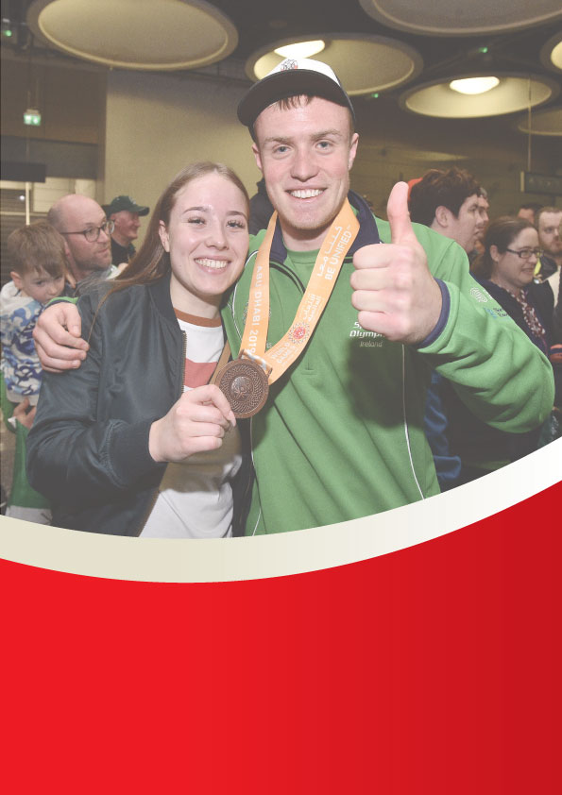

Welcome Pack: Club Volunteers

Special Olympics Region:

Club Name:

Purpose of the Welcome Pack

*It is a personal gesture from the club to the new volunteer to make them feel welcome and feel effort has been put into personalising this welcome. The pack should provide useful information for a new volunteer in relation to their club and their role in the club. It also should outline expectations from the club in terms of conduct and should give direction in terms of how the volunteer can avail of opportunities to develop within the club and engage in regional activities if interested.*

*A sample Welcome Pack is included in the following pages but it needs to be amended and updated as appropriate by the Club Membership Officer and Club Chairperson to reflect your specific club and Regional contact information.*

**Sample Welcome Letter**

*[This is a sample only, you are welcome to use it or amend as you see fit]*

**Letter from the Chairperson**

Dear *[insert name]*

On behalf of *[insert club name]* Special Olympics Club, I’m delighted to welcome you to our club. I hope that your volunteering experience here will be an enjoyable and rewarding one. I appreciate your time is important to you and would like to sincerely thank you for choosing our club to volunteer with.

*[insert club name]*  Special Olympics Club has been in operation since *[insert year]*. There are currently *[insert number]* athletes in the club supported by *[insert numbers]* volunteers. We offer the following sports: *[insert sport/s].*

*[insert what is appropriate from the following]* We also facilitate the Athlete Leadership, Health and Well-Being programme, Young AthletesTM programme.

While in your volunteer role, I would encourage you to look for opportunities to learn as much as you can and aim to progress within the club when opportunities arise. Your feedback is encouraged and welcome. If you have any questions, please ask. As volunteers, we are here to support each other.

Included in this pack, are details of the other members of the Volunteer Management Team, the volunteer code of conduct and a list of key dates for us in this club in the coming year. Please take a little time to familiarise yourself with its contents.

As volunteers, our aim is to have a well-run club with a team of engaged volunteers who support athletes achieve through sport and facilitate the best possible experience and outcomes for them.

By volunteering, you are contributing to that experience.

Once again, welcome, I look forward to you volunteering with us

Yours sincerely,

_________________________

*[insert name]*

Club Chairperson

**Code of Conduct for Volunteers**

As a volunteer, you have the right to:

* be treated with dignity and respect as a co-worker, not just as free help
* be given as much information about the organisation as possible, including information about our athletes, where appropriate, and policies and programmes
* have adequate training provided to ensure you complete your role to the best of your ability
* attend a place of work that is orderly, conducive to work and worthy of the job to be done, is safe and complies with health & safety regulations
* have the freedom to make suggestions and receive good feedback that shows respect for your opinion
* make complaints and have an effective complaints procedure
* be assigned to a role (if possible) that recognises your personal preference, life experience, education and employment background as well as recognising the needs of the organisation

As a volunteer, you have a responsibility to act appropriately as representatives of Special Olympics Ireland and to:

* comply fully with the registration process and receive clearance from central office to work as a volunteer
* ensure that your attitude and behaviour towards the athletes at all times respect the rights, dignity and worth of every human being
* maintain appropriate boundaries and respect the privacy of athletes at all times
* Respect the physical integrity of the athletes. This should not preclude any normal spontaneous expressions of warmth or happiness provided they are acceptable to all parties
* Be sensitive to the possibility of becoming overly involved or spending a disproportionate amount of time with any particular athlete
* Ensure that the facilities you use for activities with athletes are safe and secure and that appropriate supervision is in place before organising sports and other activities
* Ensure that there is access to the following where appropriate to our role and responsibilities
* A list of names, addresses and contact numbers for parent/Guardian/carer of the athletes in your care
* All Athletes have completed Registration Forms
* A telephone for immediate contact to emergency services if required
* Any other relevant information concerning the athletes
* Abide by Special Olympics Ireland policies and procedures

**Our Club Management Team**

|  |  |  |
| --- | --- | --- |
| **Role** | **Name** | ***Insert photo*** |
| Club Chairperson |  |  |
| Club Secretary |  |  |
| Club Sports Officer |  |  |
| Club Safeguarding Officer |  |  |
| Club Treasurer |  |  |
| Club Membership Officer |  |  |

**How you can contact the club**: *insert club contact name, number and email address as appropriate*

**Key Dates for our club this year**

* Xxx
* Xxx
* Xxxxx
* Xxxx
* Xxxxx
* Xxxxx
* Xxxxx

**Development Opportunities**

Education and upskilling opportunities are a key part of the volunteer journey in the organisation. Development opportunities are part of our committment to support you, just as you give your time and energy to us.

Our objectives when setting out a pathway for development are:

* to equip you with the skills to perform your role(s) effectively and confidently
* to ensure that you are aware of the opportunities for growth and progression in the organisation.
* to recognise and address the needs of volunteers who will assume key management roles
* to meet the needs of our strategy and also legislative and good governance requirements across all roles

Development starts from your induction and moves forward with you via a learning pathway focused on each volunteer role so it is timely and relevant. Opportunities are both internal and external to Special Olympics and include Coaching, Event and Competition management, Club Development, Safeguarding, Athlete Mentoring, Board and Committee role support, and Intellectual Disability Education.

**Other Volunteer Opportunities**

**Events**

A range of sports competition events take place across your region throughout the year. Each event differs in size and scale depending on the needs of the athletes, sports being offered and facilities available. Such events are run by and with volunteers in cooperation with your regional Special Olympics office. Sports events provide a wonderful experience for athletes and volunteers alike. If you would like to get involved in an event, please go to [www.specialolympics.ie](http://www.specialolympics.ie) and search for a calendar of events in your region. If interested, you can express your interest online as prompted or contact your regional office *[insert details of individual/appropriate SO Regional Development officer]*

**Fundraising Events**

A number of fundraising events take place each year in all regions, e.g., Polar Plunge, Collection Day which raises money for the Special Olympics Ireland Programme which benefits all regions. Volunteers play a huge part in organising and delivering on such events. If you are interested in getting involved in such activities outside of your club, please log on to [www.specialolympics.ie](http://www.specialolympics.ie) and access your regional fundraising page for more information. Alternatively you can contact your regional office at *[insert Regional Contact details here]*