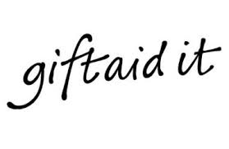

If you are a UK taxpayer your donation could be worth an additional 25% at no extra cost to you!

Yes – I am a UK taxpayer and would like to Gift Aid all donations to Special Olympics Ireland now and in future. I allow Special Olympics Ireland to back date Gift Aid on any donations I have made over the past 4 years. I understand I must pay enough income tax and/or capital gains tax each year to cover the amount of Gift Aid on my donation in the tax year, and I am responsible for paying any difference.
Please remember to let us know if your tax status, name or address change or if you wish to cancel your Gift Aid declaration.

Full Name: _________________________________________________________________

Address:___________________________________________________________________________

__________________________________________________________________________________

