INFORMATION SHEET FOR ATHLETES & VOLUNTEERS

 | Remember to wash your hands before going to training and use sanitiser when you get to your club.
 | Bring your own water bottle with your name clearly marked on it and come dressed ready for training.
You should only travel to you activity with members from your own home/place of residence.
If using Public Transport a face mask must be worn as per COVID-19 Government guidelines.
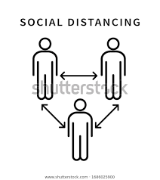 | Follow instructions from your coaches and volunteers about keeping your distance.
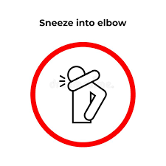 | Cough or sneeze into your bent elbow or tissue. If using tissues throw it in the rubbish bin and wash your hands.
Use a bow to say hello or foot bump to say well done.
NO shaking hands, high fives or hugs.
 | After training go straight to your car and wash your hands when you get home.

